Sometimes the right piece of artwork
makes all the difference...

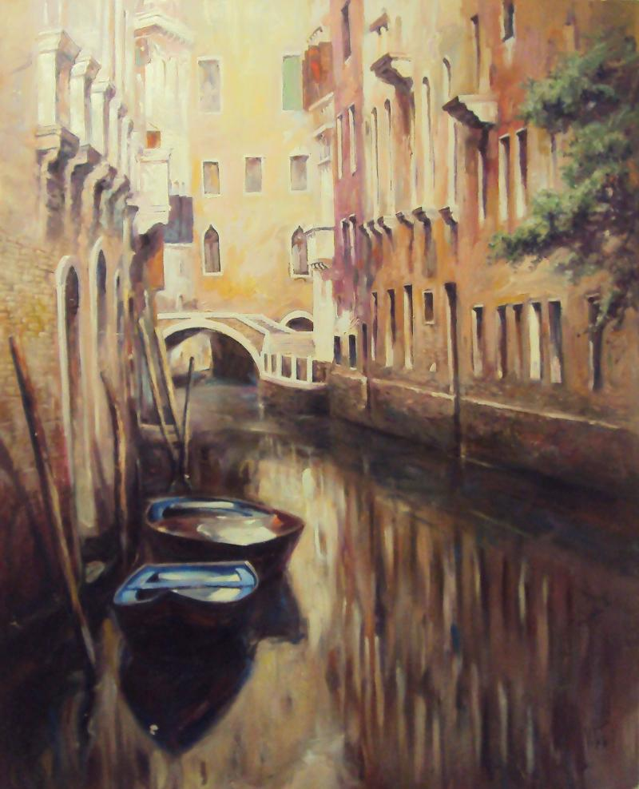

Art Shows .....all weekend long...Friday, Saturday, and Sunday
3 different times
3 different locations
Call or email Angela for specific locations and times
Food, Drinks, and solutions for your empty walls!
Please join us!

